**Assignment Exercise for Introduction to Twitter Bootstrap**

Question 1: Write the HTML code to create a table in which there are 4 columns( ID , Employee Name, Designation, Department) and at least 6 rows. Also do some styling to it.

Answer 1:

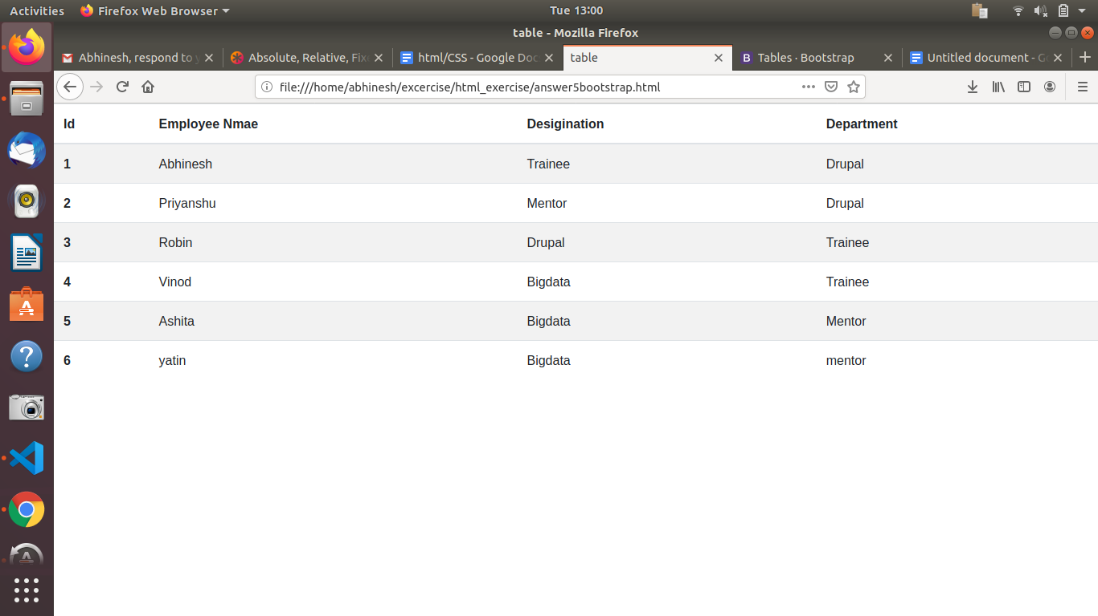

Question 2. Create HTML for web-page.jpg (check resources, highest weightage for answers)

Answer 2.

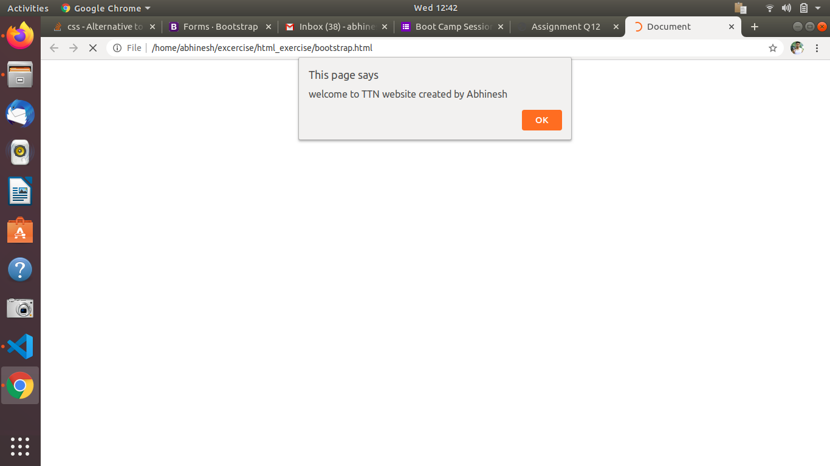

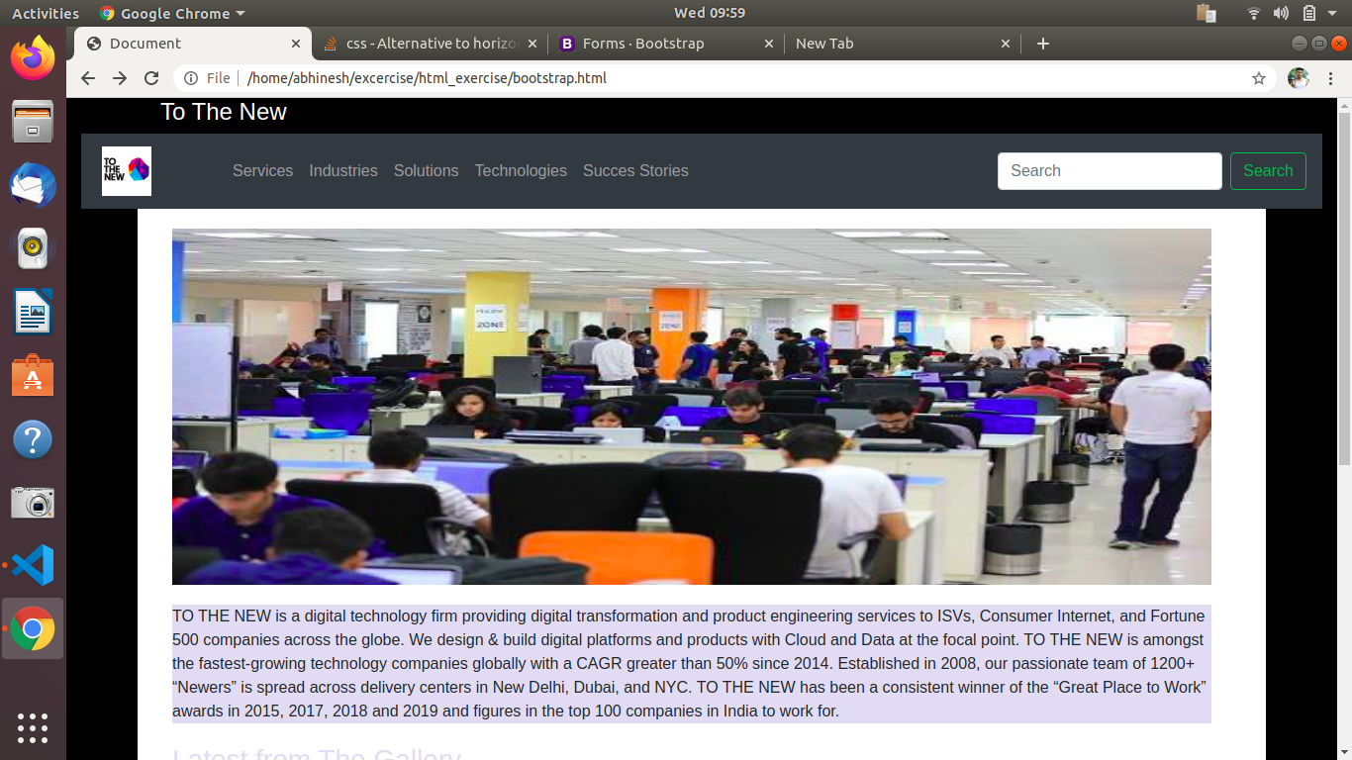

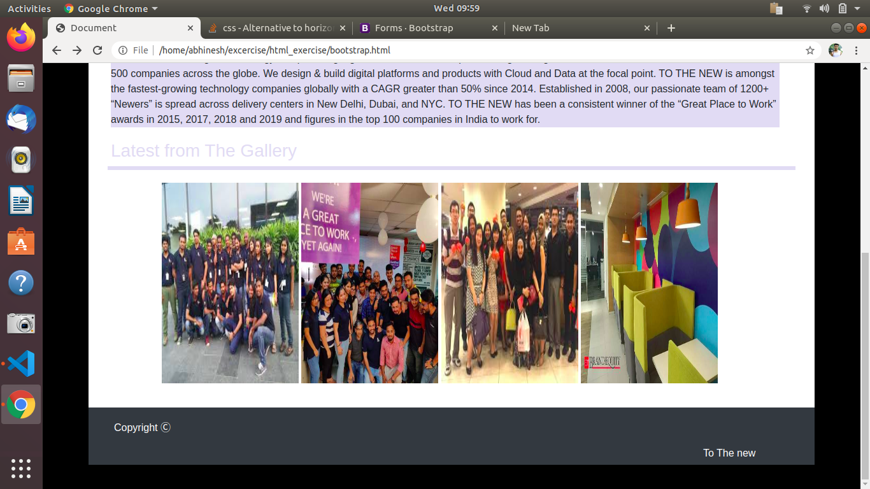

Question 3. Create HTML for form.png (check resources, highest weightage for answers)

Answer 3.

